DATA SCIENCE PROJECT PLAN & STRATEGY DESIGN
Project Title: E-Commerce Customer Churn Prediction Framework
1. Introduction & Background
Customer retention is a critical metric for e-commerce platforms, as acquiring new customers is significantly more expensive than retaining existing ones. This hypothetical project focuses on developing a machine learning pipeline using Python to predict customer churn (identifying customers highly likely to stop using the platform). By preemptively identifying these users, the business can deploy targeted retention strategies, thereby increasing revenue and customer lifetime value.
2. Project Objectives & Scope
- Objectives: Design an end-to-end framework to clean raw user data, perform exploratory data analysis, and train a supervised classification model that predicts churn with high recall.
- In-Scope: Data ingestion, handling missing values, feature engineering, exploratory visualizations, machine learning modeling (e.g., Random Forest, XGBoost), and model evaluation.
- Out-of-Scope: Real-time API integration with live databases, front-end dashboard development, and cloud-based auto-scaling deployments.
3. Methodology & Strategy
- Stage 1: Data Collection: Ingest raw demographic and transactional data using pandas (CSV formats).
- Stage 2: Preprocessing & Cleaning: Handle missing values via median/mode imputation. Apply One-Hot Encoding for categorical variables and StandardScaler for numerical features.
- Stage 3: Exploratory Data Analysis (EDA): Use matplotlib and seaborn to visualize correlation heatmaps, feature distributions, and outlier boxplots.
- Stage 4: Model Development: Split data into 80/20 train/test sets. Train baseline models (Logistic Regression) and advanced ensemble models (Random Forest, XGBoost). Mitigate class imbalance using SMOTE.
- Stage 5: Evaluation: Validate the model using 5-Fold Cross-Validation, prioritizing the $F_1$-Score and Recall metrics.
4. Visual Architecture Flowchart Blueprint
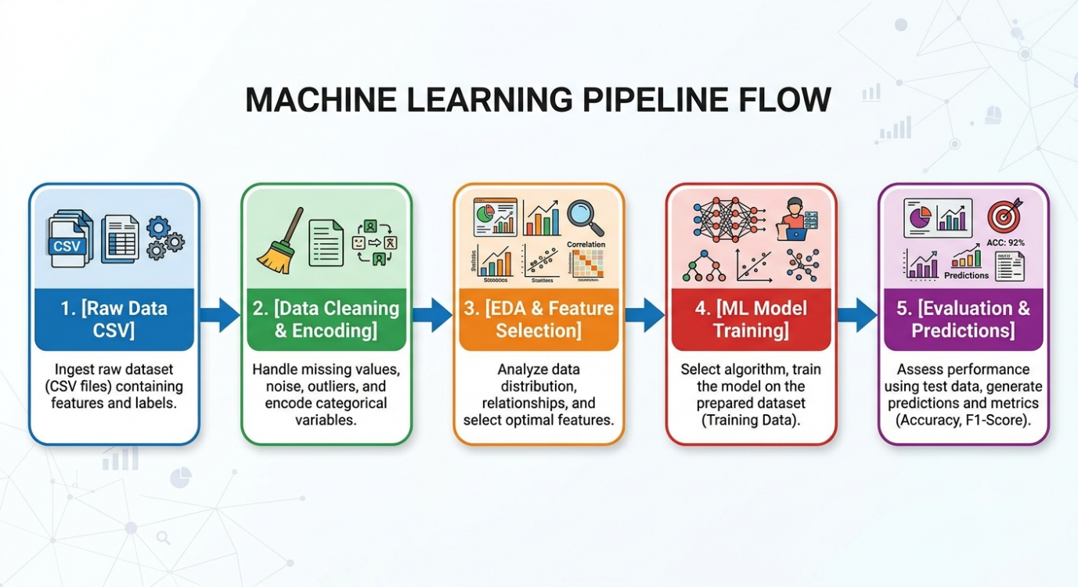5. Timeline & Tooling (35 Hours Allocated)
- Python Tech Stack: pandas, numpy, matplotlib, seaborn, scikit-learn, imbalanced-learn.
- Estimated Timeline:
  - Phase 1: Problem Scoping & Architecture Design (5 Hours)
  - Phase 2: Data Cleaning & Preprocessing Strategy (8 Hours)
  - Phase 3: EDA & Visualization Framework Design (7 Hours)
  - Phase 4: ML Model Selection & Tuning Plan (10 Hours)
  - Phase 5: Final Documentation & Reporting (5 Hours)
6. Expected Outcomes & Challenges
- Expected Outcomes: A robust predictive framework capable of identifying at-risk customers, allowing the marketing team to automate discount offers.
- Anticipated Challenges: Imbalanced datasets (few churners vs. many active users) which can skew accuracy.
- Mitigation: We will utilize SMOTE (Synthetic Minority Over-sampling Technique) and rely on Precision-Recall curves rather than standard accuracy to evaluate true performance.

